Who fights against the horrible Dragon to protect the virgin and virtuous bride from him but Michael?, Who helps Miguel in his fight against the Dragon but only those males with similar interests?
José Galindo end times revelation, Michael fights to protect the princess, his virgin bride. 24 de junio de 2023 9 minutos
Because I am the friend of God, I question and criticize the Bible, which is the book of the Romans who were the ones who stole many words from the friends of God to include them in that book. Some people imagine Yahweh’s judgment like this: Jesus comes and says to the people: «Did you follow my gospel?», the people answer them: «Which gospel?» and he asks them: «Did you love one another including your enemies (John 13:34; Matthew 5:44)?», one of them answers: «What will happen to those who did not?» then Christ answers them: «Those who did not do it will be my enemies and I will curse them with hatred saying to them: «Depart from me, you cursed ones, into the eternal fire that has been prepared for the Dragon and his angels. (Matthew 25:41).”
The chosen woman will believe the truth, unlike Eve who believed the serpent, it was precisely the serpent with the intention of frustrating God’s plan to reverse original sin, which has falsified the gospel, much of the Bible, including the book of Revelation, contain part of these adulterations, the book of Revelation, even within the 22 chapters, does not have a chronological order of events, there are incomplete or semi-adulterated remains of different symbolic narrations of the same events: Revelation 12:15 And the serpent spewed out of its mouth, after the woman, water like a river, so that she might be swept away by the river. 16 But the earth helped the woman, for the earth opened her mouth and swallowed up the river that the dragon had spewed out of her mouth. Words are weapons, Satan seeks to deceive the chosen woman with a river of words that lie against God, but «the earth» swallowed that river of lies; that is to say, many people, those who are not registered in the book, believed those deceptions without ever being able to get out of them, the woman at first will be confused, that is why she feels anguish: Revelation 12:2 And being pregnant, she cried out with pain in labor, in the anguish of childbirth. But after being enlightened with the correct information, she is freed from suffering because she understands who is that man who saves her from anguish with the power that God has given her, she perfectly understands the man who helped her, they unite in one flesh and they are happily ever after. Through the Bible the Romans presented to the world not only an incomplete and largely falsified gospel, but also through offensive images against heaven a false Christ, a long-haired and unmanly-looking one who can only be matched with a very strange man who has never been interested in taking a virgin and faithful woman for a wife; and so it is impossible that it was the Christ who was killed by the Romans on the cross. Psalms 22:16-18 Because dogs have surrounded me; A group of wicked has surrounded me; They pierced my hands and my feet. I can count all my bones; Meanwhile, they look at me and watch me. They divided my clothes among themselves, and for my clothes they cast lots. Psalms 110:4 Jehovah swore, and will not repent: You are a priest forever according to the order of Melchizedek. 1 Corinthians 11:7,13-15 For a man should not cover his head, for he is the image and glory of God; but the woman is the glory of the man. Judge for yourselves: Is it proper for a woman to pray to God without covering her head? Doesn’t nature itself teach you that it is dishonorable for a man to let his hair grow? On the contrary, for a woman to let her hair grow it is honorable to him; because instead of a veil she is given her hair. Leviticus 21:13-14 The priest of God shall take a virgin woman as his wife. He shall not take a widow, nor a repudiated woman, nor an infamous woman, nor a prostitute for a wife, but he shall take a virgin for his wife from his people. Revelation 1: 6 and he made us kings and priests to God his Father; to him be glory and dominion forever and ever. Amen. Proverbs 18:22 He who finds a virtuous wife finds good, and he obtains the benevolence of the Lord. Isaiah 66:21-24 And I will take of them also for priests and Levites, says Jehovah. For as the new heavens and the new earth that I make will remain before me, says Jehovah, so will your descendants and your name remain. And from month to month, and from sabbath to sabbath, all shall come to worship Jehovah before me, said Jehovah. And they will go out, and they will see the corpses of the men who rebelled against me; for their worm will never die, nor will their fire go out, and they will be abominable to all men. If Jehovah could come as a mortal man, he would seek Jehovah and Jehovah would make his enemies as his footstool, furthermore Jehovah would give Jehovah made man glory, honor and immortality. Psalms 110:1-2 Jehovah said to my Lord, Sit at my right hand, until I make your enemies your footstool. Jehovah will send from Zion the rod of your power; Dominate in the midst of your enemies.
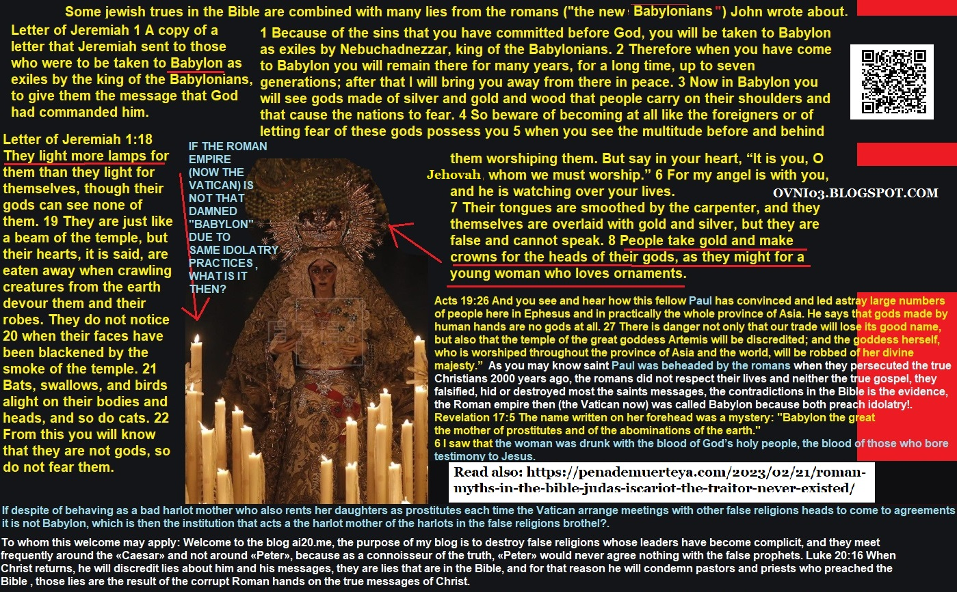
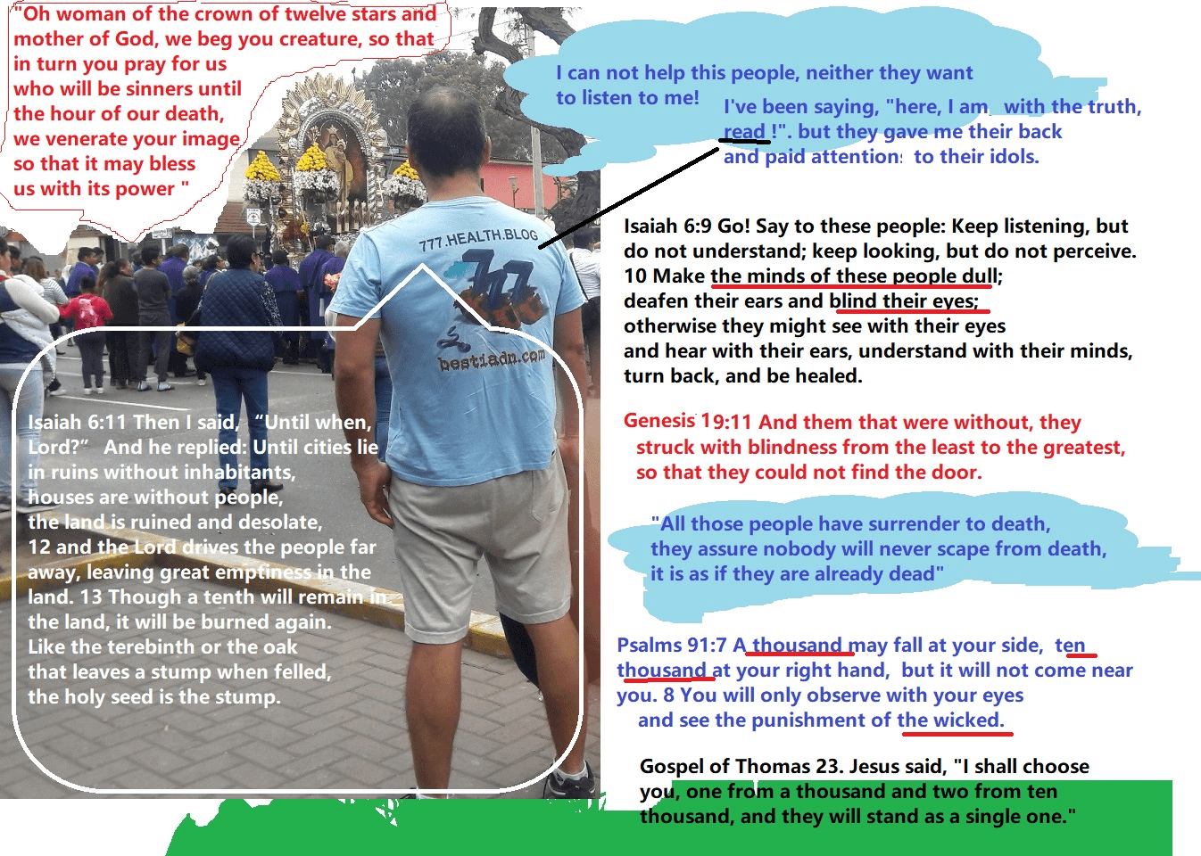
Proverbs 31:10 Virtuous woman, what man can marry her? Because her esteem far exceeds that of precious stones. Proverbs 16:4 Jehovah has made all things for himself, And even to the wicked for the evil day. Psalms 110:5-7 The Lord is at your right hand; He will break kings in the day of his wrath. He will judge between the nations, he will fill them with corpses; He will break heads in many lands. From the brook he will drink on the way, For which he will lift up his head. Daniel 12:1 At that time Michael will rise, the great prince who is on the side of the sons of your people; and it will be a time of anguish, which never was since there were people until then; but at that time your people will be released, all who are found written in the book. Who fights against the horrible Dragon to protect the virgin and virtuous bride from him but Michael?, Who helps Miguel in his fight against the Dragon but only those males with similar interests?:
Revelation 12: 7 Then there was a great battle in heaven: Michael and his angels fought against the dragon; and the dragon and his angels fought; Psalms 110:3 Your people will volunteer to you on the day of your power, In the beauty of holiness.
https://ai20me.files.wordpress.com/2023/03/the-holy-covenant-for-holy-people-the-righteous.docx
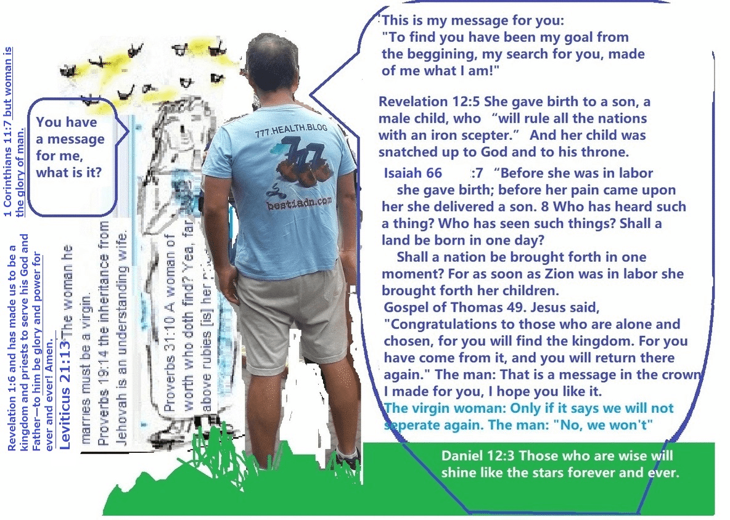
From the bosom of the dawn You have the dew of your youth. Job 33:25 his flesh will be more tender than the child’s, he will return to the days of his youth. Psalms 16:10 For you, Jehovah, will not allow your saint to become a corpse, nor will you allow his body to rot. Psalms 118: 17-20 I will not die, I will live to bear witness to the works of Jehovah, Jehovah punished me severely but he did not deliver me to death nor will he ever do so. Open the doors of justice for me; I will enter through them, I will worship only Jehovah. This is Jehovah’s gate; Only the righteous will enter through it. Revelation 21:27 And nothing unclean shall ever enter it, not even those who practice and love abominations or slander, but only those whose names are written in the Lamb’s book of life.
https://lavirgenmecreera.com/2023/06/24/who-fights-against-the-horrible-dragon-to-protect-the-virgin-and-virtuous-bride-from-him-but-michael-who-helps-miguel-in-his-fight-against-the-dragon-but-only-those-males-with-similar-interests/

